**TRANSFORMERS GO! G-01 KENZAN**

**ROBOT TO CAR TRANSFORMATION**



This is Kenzan. He is one of the members of the Samurai Team of Swordbots. He transforms into a futuristic police car, and comes with two swords and chest armor (called a “kabuto”). Unfortunately, however, Kenzan is a Japanese-made toy and it can be hard to understand how he works at first glance.

1. Pull the head down into the chest. **Note:** Kenzan has a little topknot on his head that must also be pulled down.

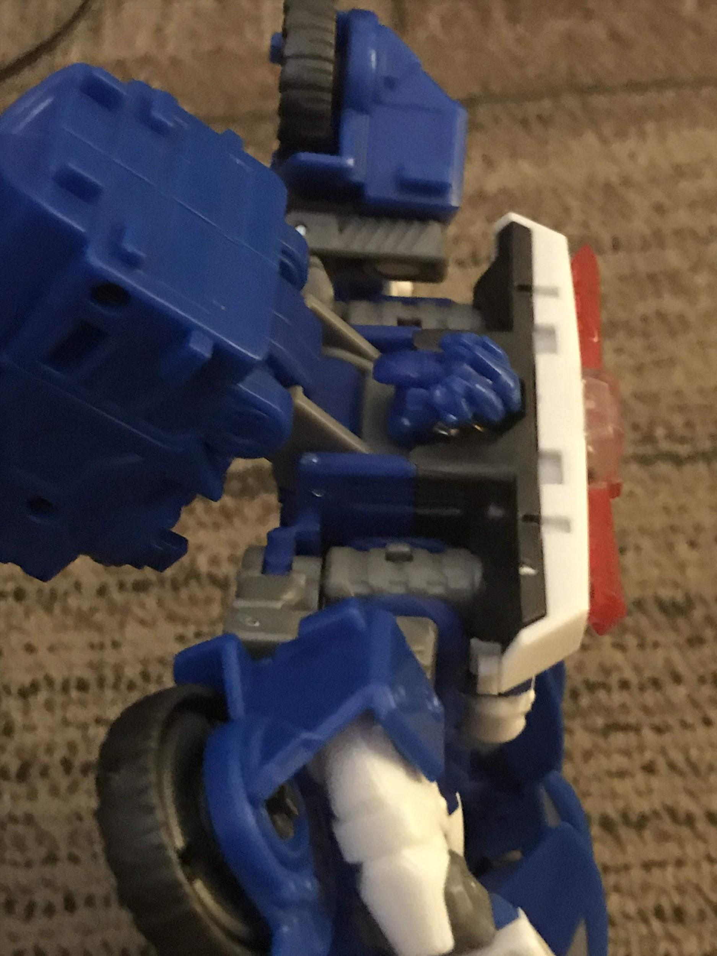

1. Pull up Kenzan’s battery pack (the large blue cylinder on his back) so that it covers where the head was. There are tabs in the neck area that connect to the battery pack.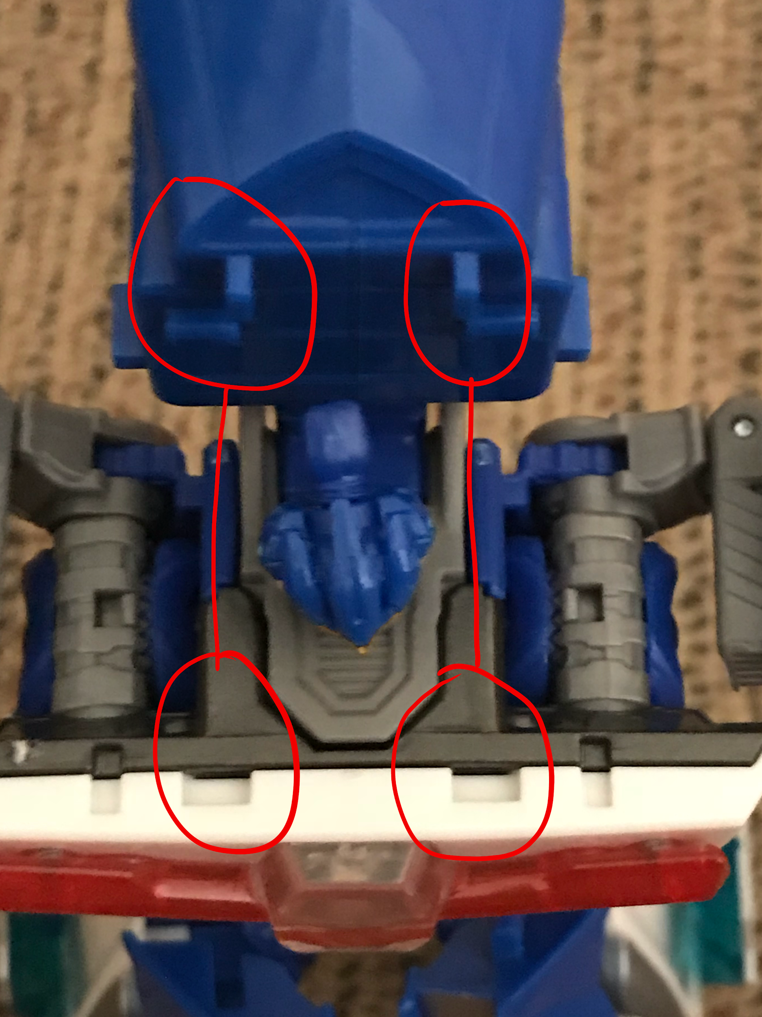
2. Fold up the blue crotch piece.
3. Completely fold up Kenzan’s arms and attach them to the battery pack. First, extend his arms all the way out, and then fold the grey portion down. **Note**: The grey parts on his arms do bend, although it will take some force to connect them. There are also tabs on his arms that attach to the battery pack.

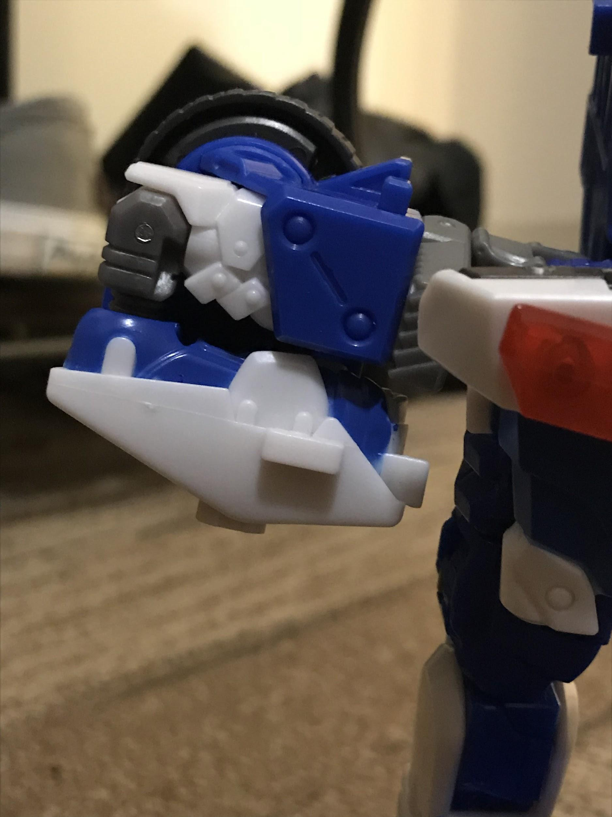

1. Kenzan has blue parts on the back of his legs that fold inwards. Fold in his legs.

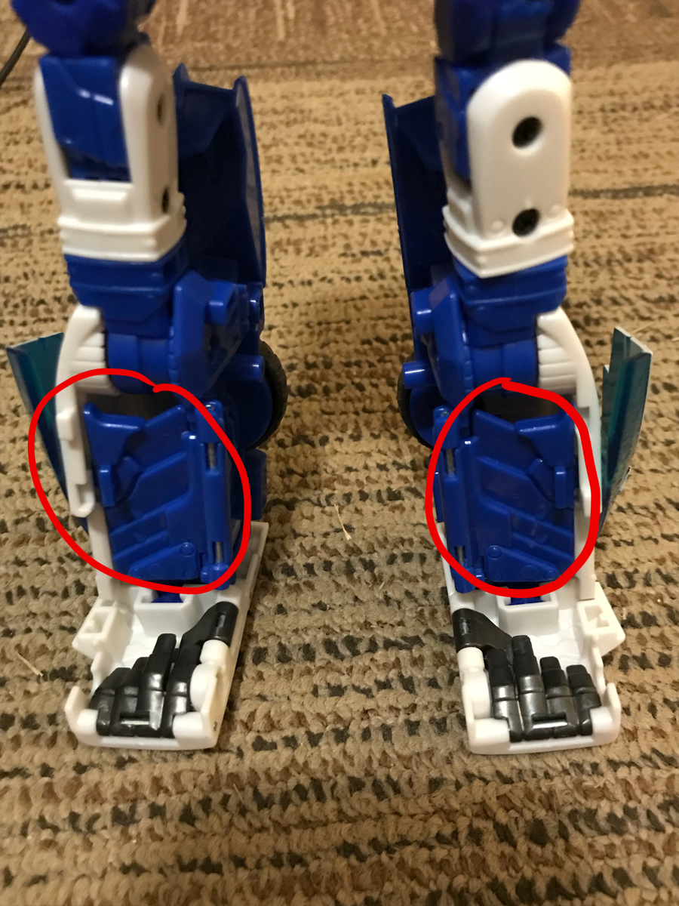

1. Fold his feet and toes up and expose the front half of the car.
2. Fold up the windshield (blue translucent part) so that it fits in with the rest of the front half of the car.

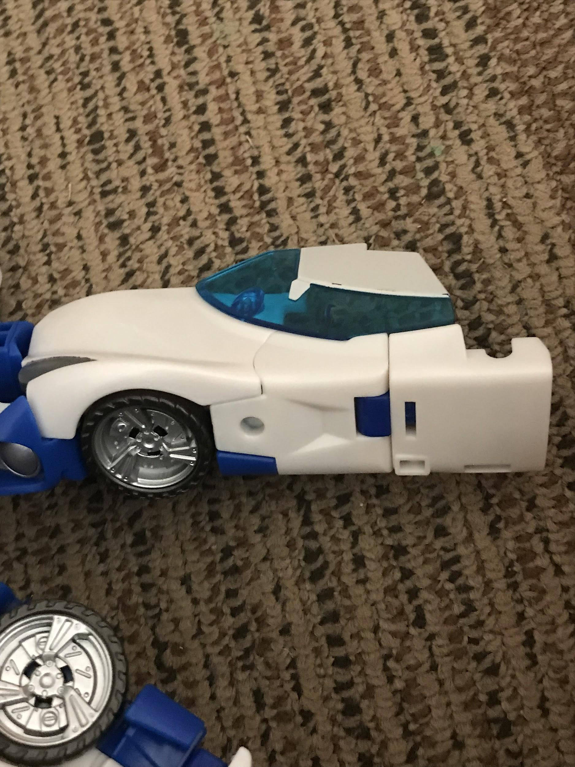

1. Fold up the legs vertically so that they connect to the arms. First, fold them 180 degrees, then pull them up.

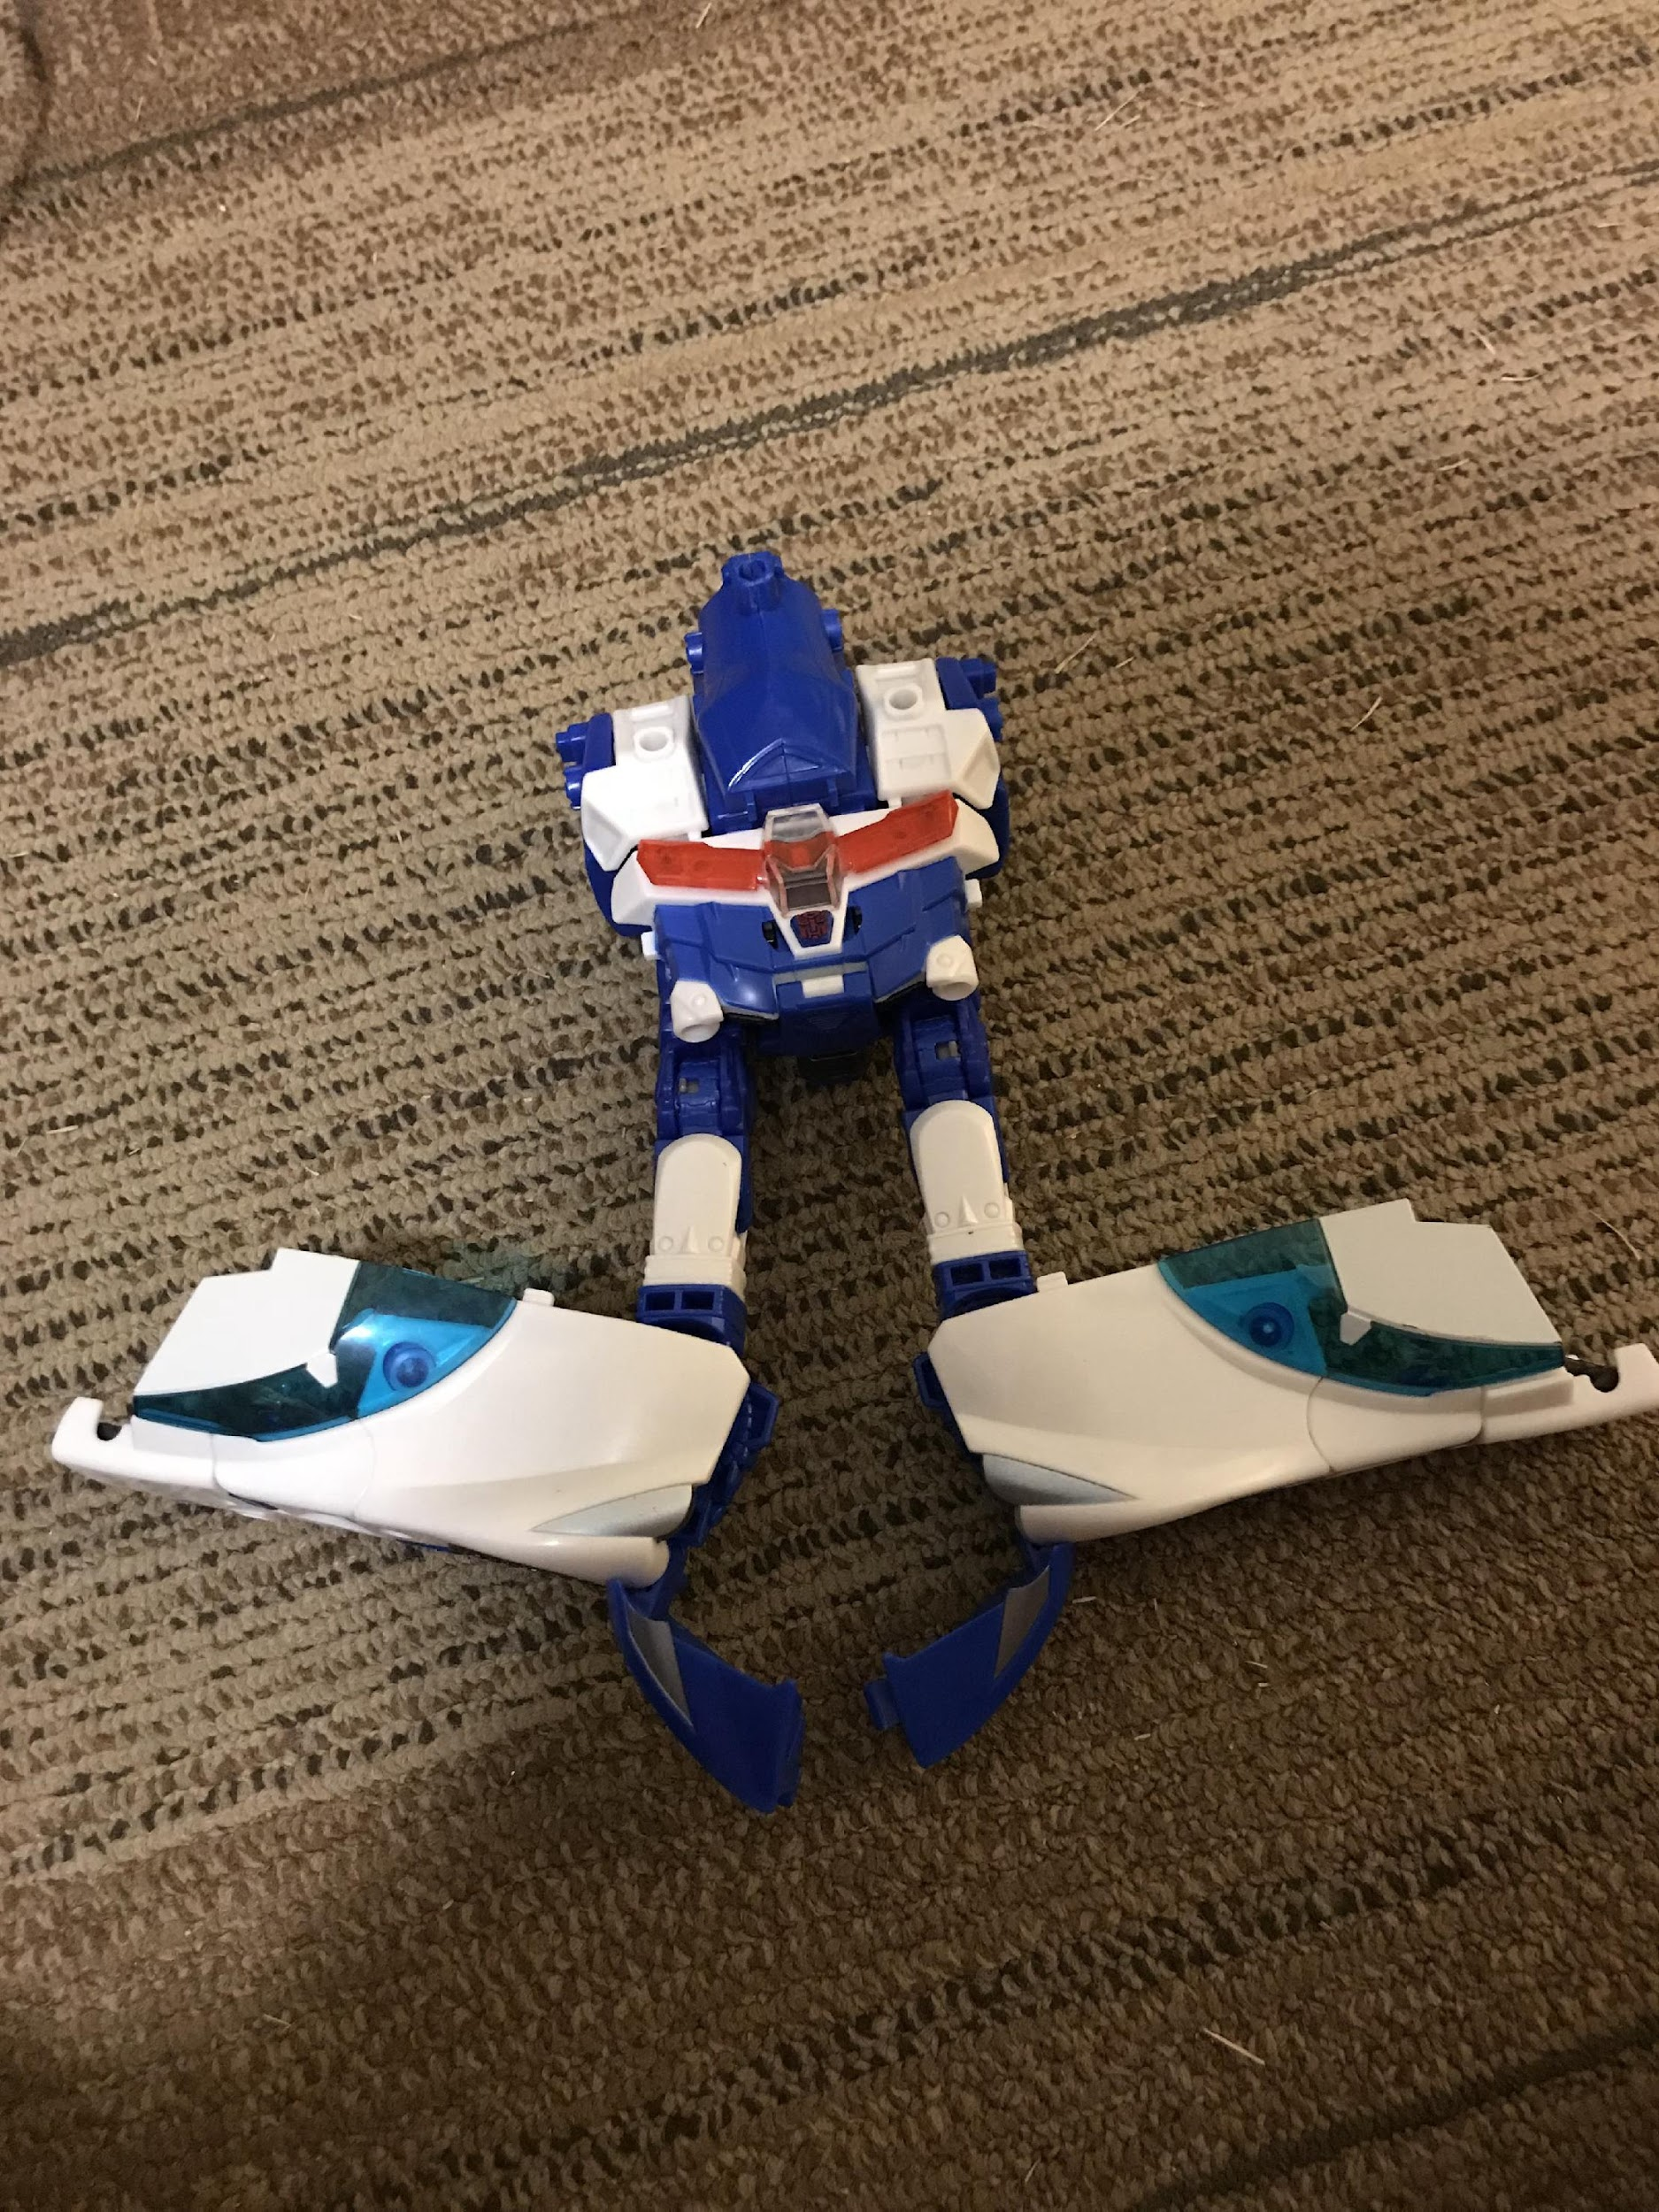

1. Pull out the dark blue parts of the legs (front part of the car) and connect them

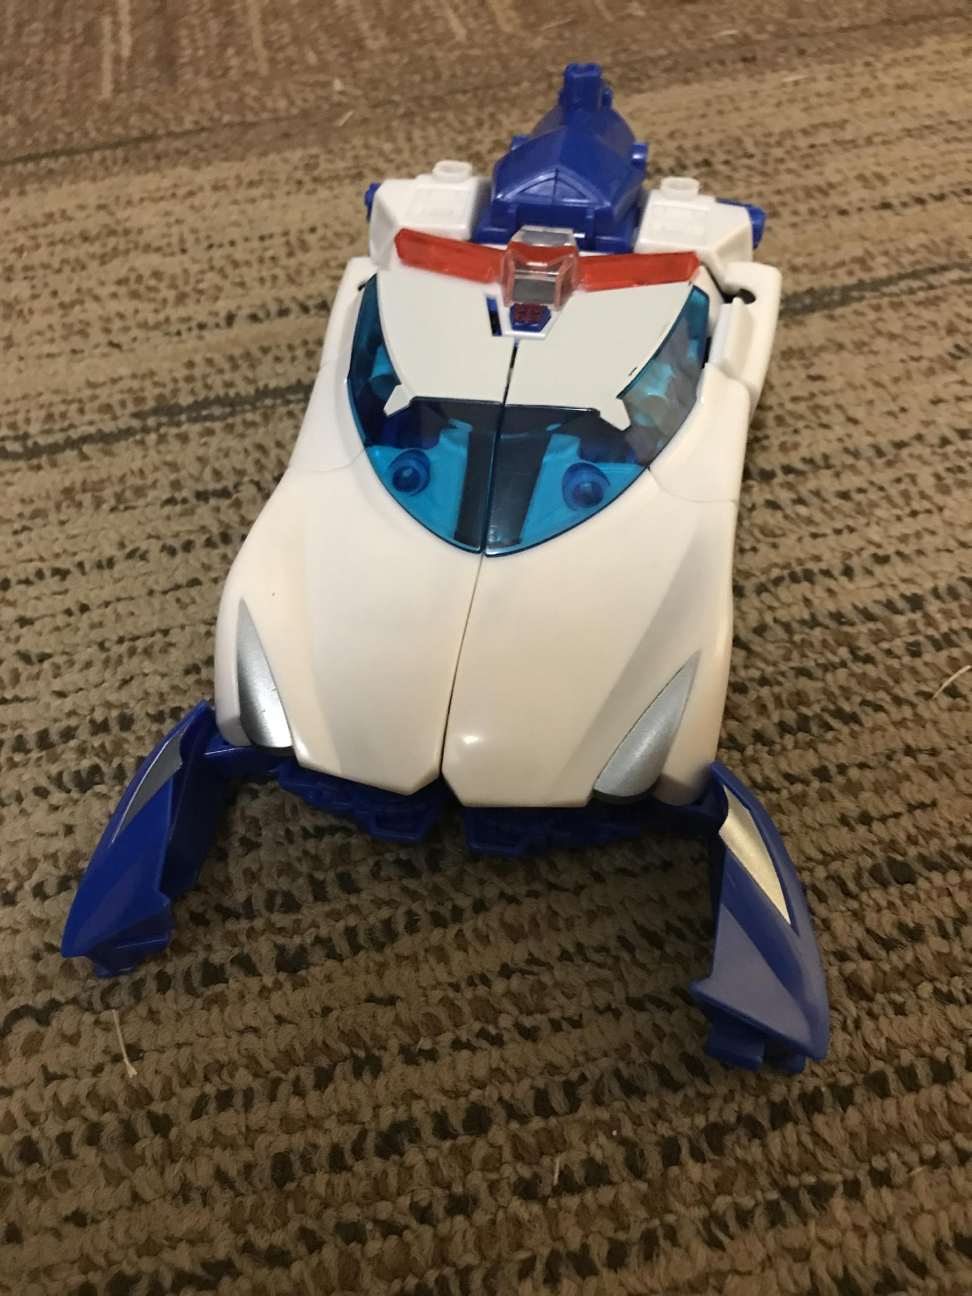

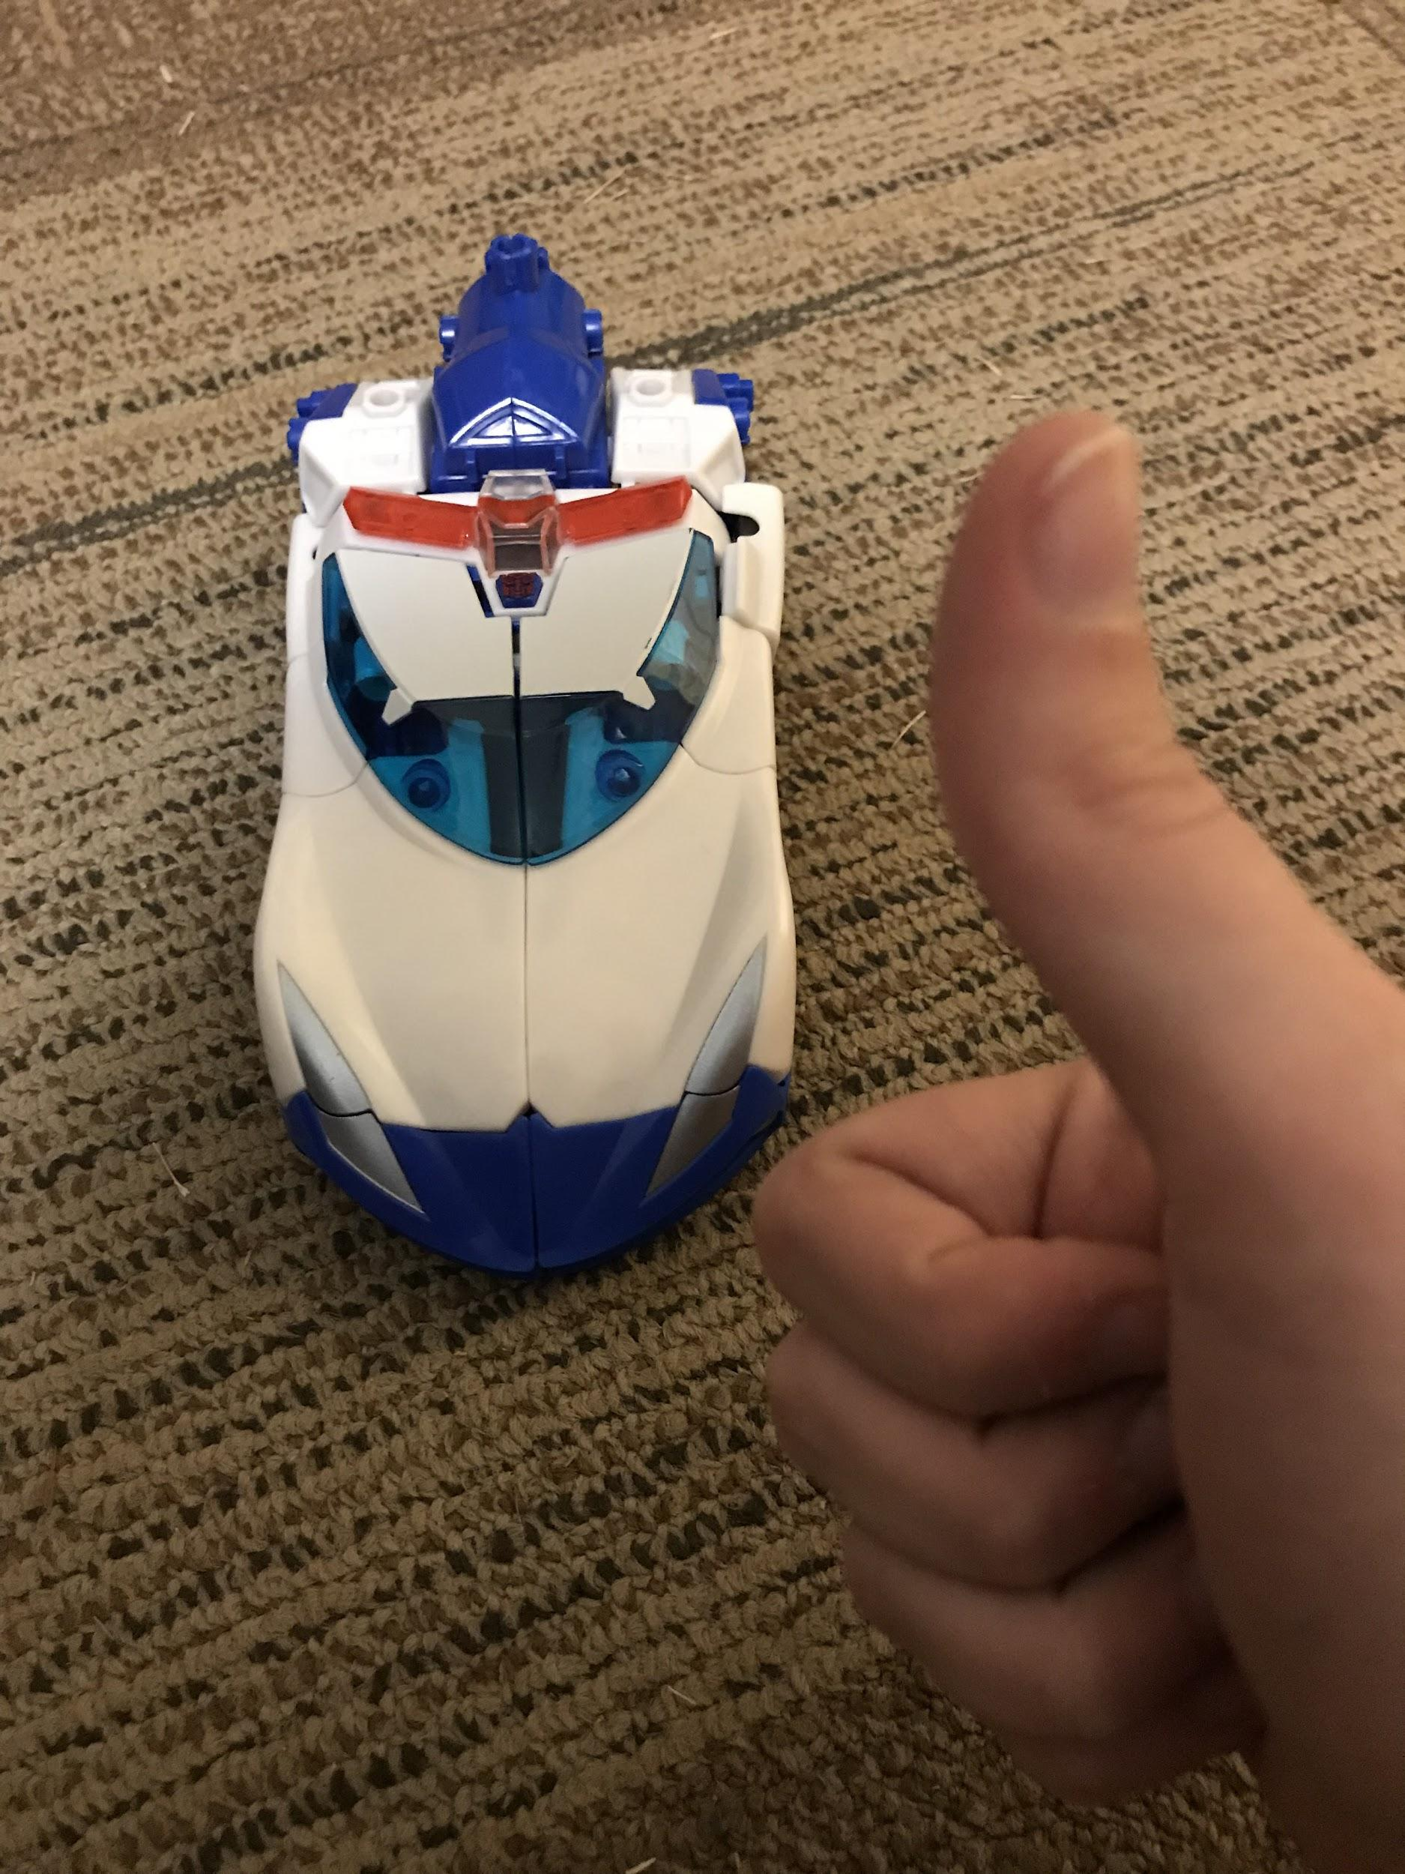

This is what the finished product should look like. You can store his Kabuto and his two swords on the battery pack.To detransform, simply reverse the steps.